Please indicate required parameters instead of red tinted ones below (fill areas __________).

Concave ON AXIS PARABOLIC MIRROR | SPECIFICATION (see drawing left)
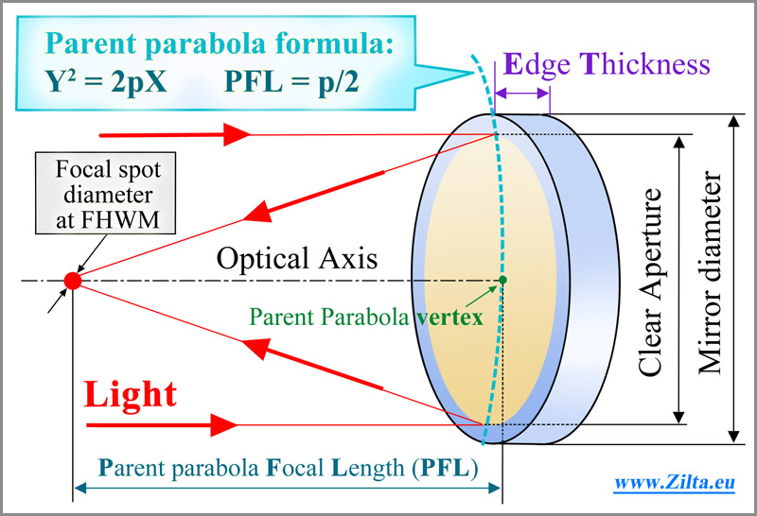 | Substrate material (AstroSitall®, Zerodur, Fused Silica, etc.) | _________________
 | Mirror diameter, [mm] | ____ +0, -0.5
 | Mirror Edge Thickness (ET) , [mm] | ____ ±0.5
 | Clear (Work) Aperture (CA), [mm], | ____ +0.5, -0
 | Parent Parabola Focal Length, [mm] | ____ ±0.5%
You can set the accuracy of mirror surface manufacturing you need in the
following three ways (at least one of them You have to choose), please indicate:
 | First way: surface figure accuracy  (at test Lambda=633nm, RMS or/and P2V) | RMS λ/____  or/and P2V λ/____
 | Second way: Slope Error, [arcSec]  (at test Lambda=633nm, RMS or/and P2V) | ____
Standard specification:  Back surface: flat, ±10’ to optical axis of the mirror  Non optical surfaces: fine ground ~45µm; chamfering  Marking: Individual #;  Work environment:  Laboratory, +10°C …+45°C, no baking,  Max humidity 70% | Third way: desirable focal spot diameter [FHWM, µm] | ______
 | Surface quality, [Scratch-Dig], choose at full CA or at 1”  Micro-Roughness, RMS [nm] | __-__  ______
 | Desirable coating specification  or work wavelength range and coating requirements | ______
 | Mounted or not?  If mounted – mounting requirements? | ______
Some other important data or notes?

Please send this completed form to quote@lasertechn.com to quote it.
If it’s neseccary please add in attachment to Your letter other files.

