Please indicate required parameters instead of red tinted ones below (fill areas __________).
Also for best quotation You may fill areas with green line.
Concave OFF AXIS PARABOLIC MIRROR | SPECIFICATION (see drawing below)
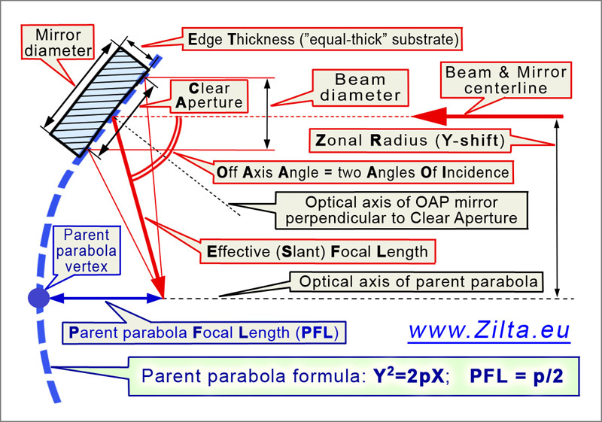 | Substrate material (Astro Sitall, Zerodur, Fused Silica, other?) | _________________
 | Mirror diameter, [mm] | ____ +0, -0.5
 | Mirror End Thickness (ET) , [mm] | ____ ±0.5
 | Clear (Work) Aperture (CA), [mm], | ____ +0.5, -0
 | Beam diameter, [mm], | ____
 | Effective (or Slant, Reflective) Focal Length, [mm] | ____ ±0.5%
 | Parent Parabola Focal Length, [mm] | ____ ±0.5%
 | Zonal Radius (Y-Shift, Off Axis Distance to center), [mm] | ____ ±0.5%
 | Off Axis Angle, [arc degrees] | ____ ±0.5%
 | Surface figure accuracy (Appendix 2)  (at test Lambda=633nm, RMS or/and P2V) | RMS λ/____  or/and P2V λ/____
Standard specification:  Back surface: perpendicular to optical axis of mirror  Non optical surfaces: fine ground ~45µm; chamfering  Marking: Individual #; Arrow to Vertex;  Work environment:  Laboratory, +10°C …+45°C, no baking | Surface quality, [Scratch-Dig], choose at full CA or at 1”  Micro-Roughness, RMS [nm] | __-__  ______
 | Desirable coating  or work wavelength range and coating requirements | ______
 | Mounted or not?  If mounted – mounting requirements? | ______
Other important notes, requirements or something else?
Please describe them here.

