Please indicate required parameters instead of red tinted ones below (fill areas __________).
Also for best quotation You may fill areas with green line.
Concave OFF AXIS PARABOLIC MIRROR | SPECIFICATION (see drawing below)
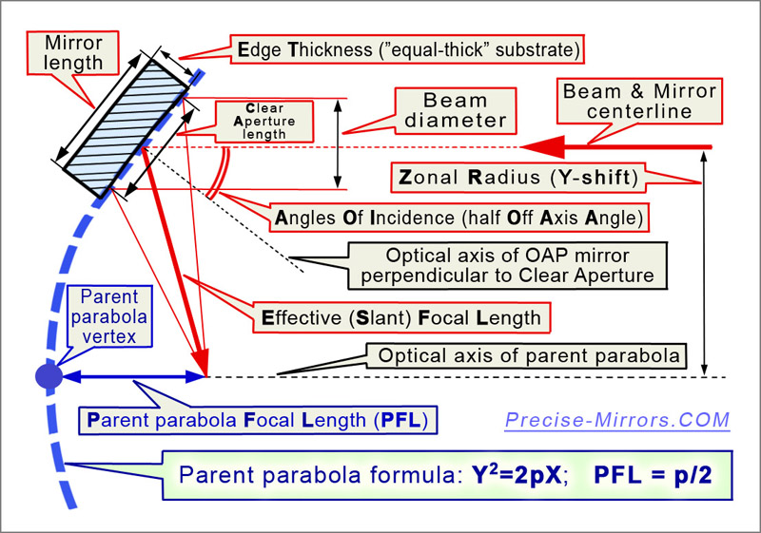  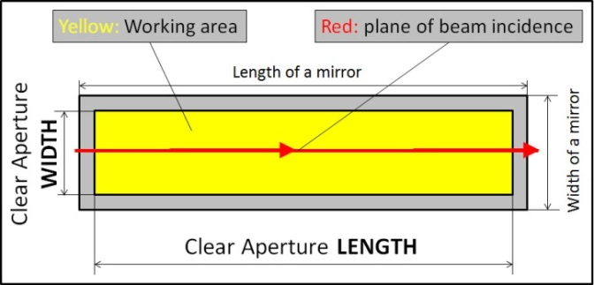  Standard specification:  Back surface: perpendicular to optical axis of mirror  Non optical surfaces: fine ground ~45µm; chamfering  Marking: Individual #; Arrow to Vertex;  Work environment:  Laboratory, +10°C …+45°C, no baking | Substrate material (Astro Sitall, Zerodur, Fused Silica, other?) |  | Astro Sitall by deafult
 | Beam size (diameter by default), [mm], ±0.5 |  | ________
 | Clear (Work) Aperture ≡ CA  CA Length, [mm], +0.5 -0  CA Width, [mm] , +0.5 -0 |  | ≥ beam diameter / Cos(AOI);  ≥ beam diameter.
 | Mirror length & width, [mm] +0, -0.5  Mirror End Thickness (ET), [mm], ±0.5 |  | ≥ CA length & ≥ CA width;  ≥ mirror length / 7.
 | Effective (or Slant, Reflective) Focal Length, [mm] ±0.5% |  | ________
 | Angle Off Incidence (AOI), [arc degrees] ±0.5% |  | ________
 | Desirable Focal Spot Diameter, [mm] FWHM, |  | ________
 | Zonal Radius (Y-Shift, Off Axis Distance to center), [mm] ±0.5% |  | ____
 | Parent Parabola Focal Length, [mm] ±0.5% |  | ____
 | Surface figure accuracy (Appendix 2)  (at test Lambda=633nm, RMS or/and P2V) |  | Fill if the absence of wavefront  distortion is important for your task
 | Surface quality, [Scratch-Dig], choose at full CA or at 1”  Micro-Roughness, RMS [nm] |  | __-__ actual for visible range  ______
 | Work wavelength range [nm], mark if eV is used  and desirable coating requirements |  | ________  ________
 | Mounted or not?  If mounted – mounting requirements? | ______
Other important notes, requirements or something else?
Please describe them here.

