Please INSERT your parameters on YELLOW place.

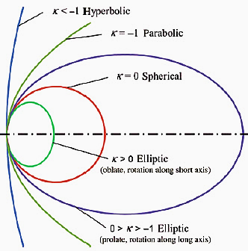
Y²-2Rx+(K+1)x²=0, where  K=………. R=………. [mm] | Ellipsoid like  a rugby balls?  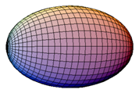  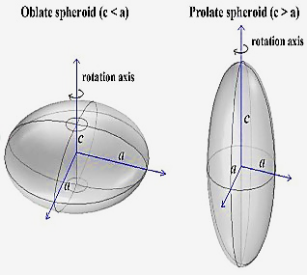  Please inform us if a inquired  ellipsoid not like a rugby ball. | Prolate, rotation along long axis  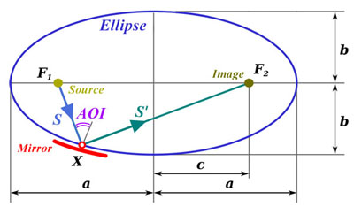  Ellipsoidal surface Mirror: Z²/a²+(X²+Y²)/b²=1  MOST parameters: work spectral range,  S (XF₁); AOI; S’ (XF₂); focal spot diameter
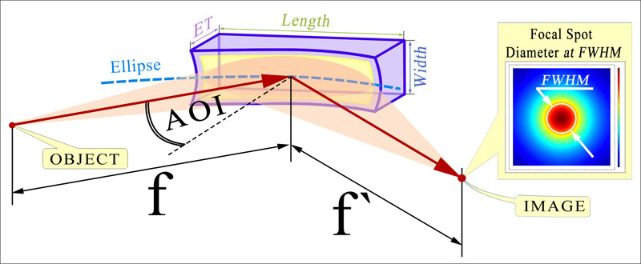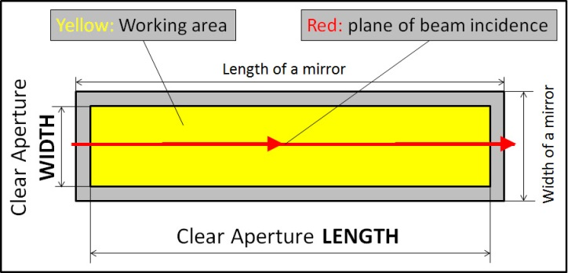
SPECIFICATION |  | Inquired meaning | Notes
1. DIMENSIONS (equal-thickness of concave mirror ) |  |  | Technological standards of ZILTA  (see drawings above)  (bevels 0.5x45°)
- Length x Width (or Diameter) [mm]  - Clear Aperture (CA), [mm]  - Edge Thickness (ET), [mm] | ........... +0 -0.5  ........... -0 +1  ........... ± 1
2. ELLIPCE PARAMETRS (see drawing above) ± 0.5 [%] |  |  | Inquired Specification  (see drawings above).  Precision direct measurements
2.1. Entrance arm S (focal length to source F₁X), [mm]  2.2. Exit arm S ‘ (focal length to source XF₂); | S = ...........  S ‘ = ............
2.3. Angle of Incidence (AOI), [degree], ± 0.5 [%] | ...........
2.4. Side 1: ellipsoidal, [mm] : a = ........... ; b = ........... ; c = ...........
2.5. Side 2: plane, parallel to Side 1; no beams ( bevels 1x45°) Marking
3. Surface accuracy or Slope Error (at λ test=632.8nm) |  |  | Test & Inspections scheme
3.1. Root Mean Square (RMS)  or (and) Peak To Valley (P2V) | λ / ...........  λ / ........... |  | Fill if the absence of wavefront distortion  is important for your task
3.2. Slope Error (RMS) -Tangential [arcSec]  (at spatial sampling) - Sagittal [arcSec] | ...........  ……. |  | 2D micromap of surface figure at CA  For example: SEtang ≈ tan [(λ/N rms) / Length]
4. Focal spot diameter (FWHM), [µm] | ........... |  | Precision direct measurements
5. Cosmetic quality or (and) [scratch/dig]  Substrate Roughness, RMS [nm] |  |  | Roughness measurement (at 0 °)
Preferable substrate material (if there is preferences)
Working wavelength range, nm (mark if eV is used) | ...........
Preferable coating (if there is preferences)
Some other important data or notes?

Please send this completed form to quote@lasertechn.com to quote it.
If it’s neseccary please add in attachment to Your letter other files.

